**Hilton Olympia – 2 min walk**

* Breakfast served between 6:30-10:30 (let Borja know of any dietary requirements)
* Breakfast area seats 125 and there is also a private dining area for 40 people
* Executive lounge locates on 2nd floor accessible by stairs or lift, seats 44 people, computers available, open throughout the day, closes at 10pm.
* Wi-Fi- free in shops
* Free Gym
* Costa coffee
* £35 for 24 hour parking
* Service animals and pets allowed a non-refundable deposit of £35. Maximum weight 75lbs

**Rooms**

* Children under 16 stay for free, a standard room will fit a roll out bed but it is more suitable to upgrade to an executive room for a supplement.
* Wi-Fi £5 for 24 hours
* **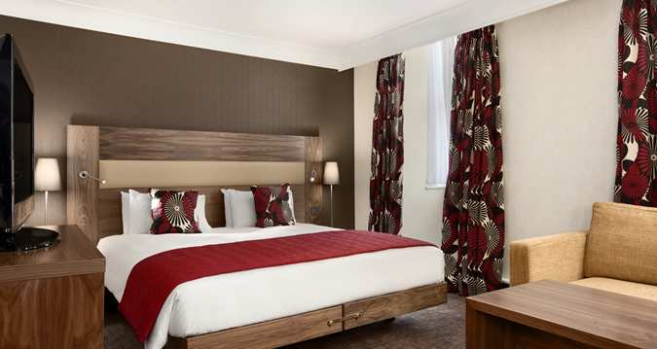**Connecting rooms available
* Smoking rooms are available
* Charged mini bar, (guest provides credit/debit card details at reception and it will automatically go onto the bill.
* Freeview available on TV
* 20m² of contemporary space in a guest room, 42m² of space in a suite

**Conference rooms**

* All located on ground floor
* Westminster suite seats 280 banqueting style and 350 standard reception
* Pembroke suite can be separated into 3 rooms, depending on number of people.
* Extra charge for lunch/tea/coffee breaks and it can be located inside or outside the room
* Extra charge for hiring out rooms depending on company requirements

**Dining**

* Costa Coffee Mon-Fri 7am-7pm Sat-Sun 8am-7pm
* Society Bar Mon-Sun 11am-1pm
* Society Restaurant Mon-Sun 6.30am-10.30pm Booking 0207 856 1980 or online

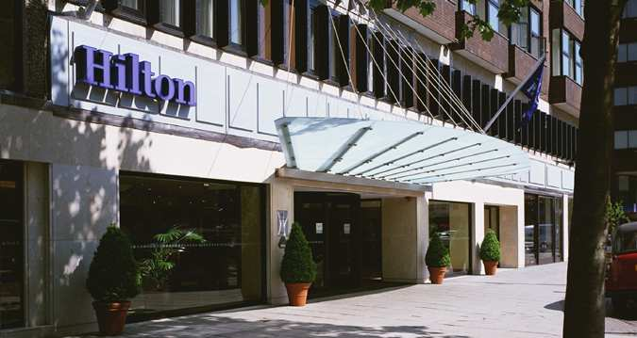

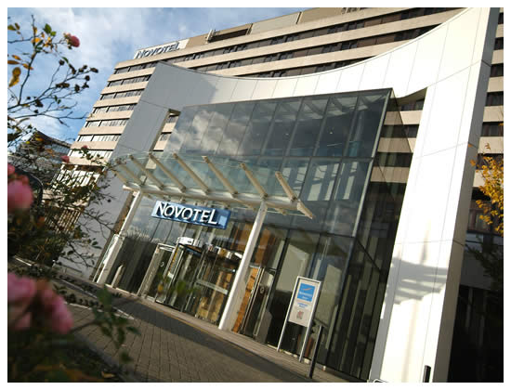**Novotel – 10 min walk**

* Breakfast served 6-11am weekdays and 6am-12pm weekends
* 24/7 complimentary gym
* Cash ATM available in hotel
* Parking £1.50 per hour
* Extra charge of £15 for pets in rooms
* Group check in on lower level: good access for coaches, group drop off, left luggage is £1 per bag per night.

**Rooms**

* Standard twin rooms available, located on the 3rd floor
* Complimentary Wi-Fi (£9.95 for 24hour upgrade to faster Wi-Fi for streaming videos etc.)
* Mini bar available at charge
* Executive rooms on 4th floor, up to 4 people with 2 under 16s or 3 adults)
* Docking station for iPod
* Interconnecting rooms available for families, sleeps 2 in each room but no sofa.
* 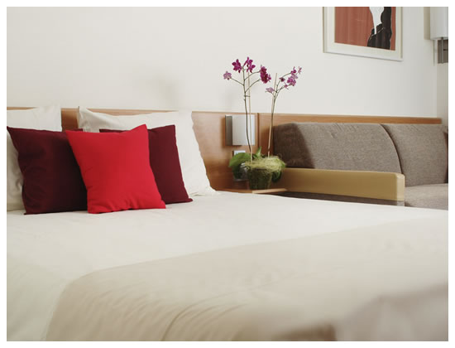Flyover side of hotel is very quiet, double glazed windows but if the individual requests a quieter room they will try and allocate them to the other side.

**Conference rooms**

* 32 conference rooms in total
* Chablis suite is a large exhibition hall
* Champagne suite is a large hall, fits 400-500 people
* Mouton Cadet fits 50 people for presentation, screen provided but no projector
* Cognac suite is suitable for a more relaxed meeting, has a built in bar, fits 130 theatre style, 60-70 cabaret style
* Mezzanine good for theatre and has a private room behind the main room for tea/coffee/lunch breaks
* Depending on the package the client requires there are different charges to hire out the rooms

**Dining**

* Aroma and Artisan Grill
* Both open Mon-Fri 12pm-2.30pm

and every evening, Mon-Sun 5.30pm-10pm

* Lounge bar open until 12am normally but until close if still in use by guests

**Copthorne Tara – 20 min walk**

* Wi-Fi 24 hours £10
* Cafe express Wi-Fi offer – buy a coffee and access to computer/internet for £5
* Free gym 6.30am-10pm
* Separate check in for groups
* Chargeable parking available

**Rooms**

* Double glazing on high street side
* Superior double or twin beds, tea/coffee making facilities, mini fridge, radio and alarm
* 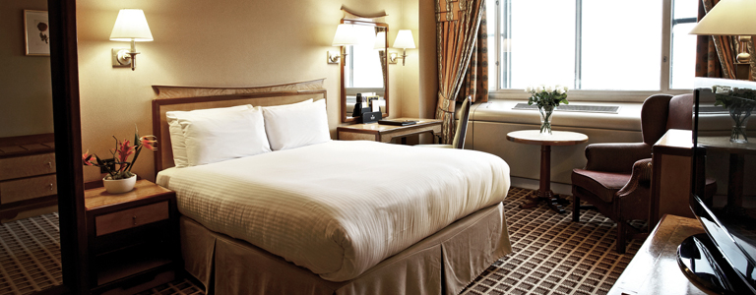Club/executive suites: £40 for Club, £150 executive free access to club lounge for breakfast, tea/coffee served all day, complimentary drinks available 6.30pm-8pm
* Complimentary Wi-Fi in club rooms
* Club rooms on 10th,11th and 12th floors bath robes and slippers, upgraded toiletries
* 10 family rooms available
* 5 executive suits, connected to lounge

**Conference** **Rooms**

* Shannon suite seats up to 300 people but can be separated into 3 different rooms for boardrooms, dinners classroom style
* Liffey suite can also be separated into different rooms
* Price based on company requirements, tea/coffee will be an extra supplement

**Dining**

* Bugis Street: Oriental cuisine served 12-10.30pm
* Artist corner: Modern British and European a la carte, breakfast served Mon-Sat 6.30-10.30am and Sun 7-11am. Dinner served 5.30-11pm daily
* The Brassiere restaurant and bar: breakfast served Mon-Sat 6.30-10.30am and Sun 7-11am, lunch served 12-3pm, dinner served 5.30-11pm. Bar open until 1.30am

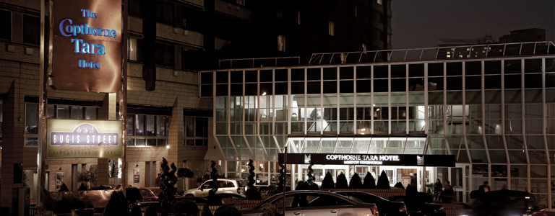

**Kensington Close – 20 min walk**

* Bar open until close Executive lounge is available for those who have club rooms
* Newly refurbished
* Wi-Fi £9.95 for 24hours.
* Spa is £8 per person per day and includes use of the gym, 18 metre, full length indoor heated pool, Jacuzzi and sauna. Yoga classes available.
* New garden
* Children under 2 stay free £20 for cot if needed

**Rooms**

* Standard room is single or double depending on guests requirements
* Executive room is £30 extra
* 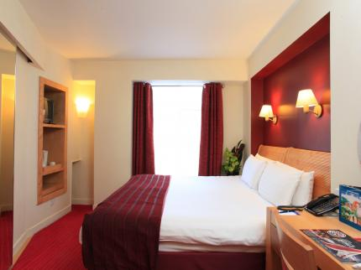Club room is queen/king size with a sofa, working desk and chair.
* Club room is £40 extra

**Conference rooms**

* Range of conference rooms available to hire for 2-250 people at an extra cost depending on company requirements

**Dining**

* Boulevard Restaurant. Breakfast is served buffet style (full English and Continental) from 6.30-10.30; lunch/dinner needs to be booked. A la carte or set menus are available for dinner
* Lounge bar 9am-1am. Food served between 9am-10pm
* Cafe Musetti Mon-Sun 6.30am-8pm
* 24 hour room service available

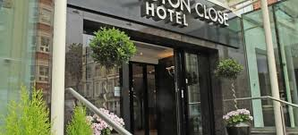

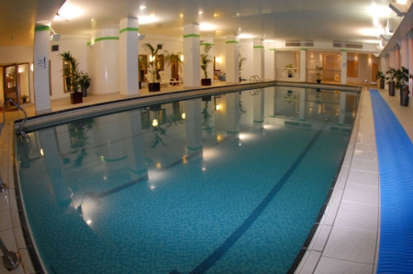

**Think Apartments - 10 min walk**

* Casual grab and go breakfast delivered to rooms night before or early morning
* Sofa bed available on request
* Apartments have oven, hob, fridge, dishwasher, crockery, pots, pans (for 4 people, utensils), washing machine and tumble dryer.
* Complimentary Wi-Fi
* Phones in every room and also located by lift on every floor
* Partnerships with fitness first, £10 per day.
* 20% discount at ‘Tesco’ Bakery
* Two bed open plan apartments have two separate bedrooms, one with en-suite available on request.
* Also have American double rooms which are bigger, 2 double beds, 2 bathrooms (at a higher rate but available on request)
* £15 clean down service is available

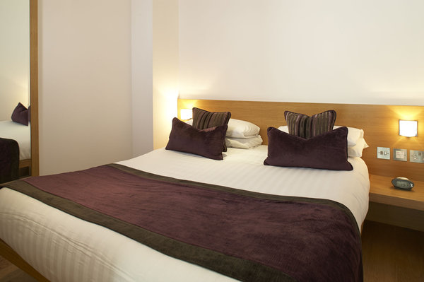

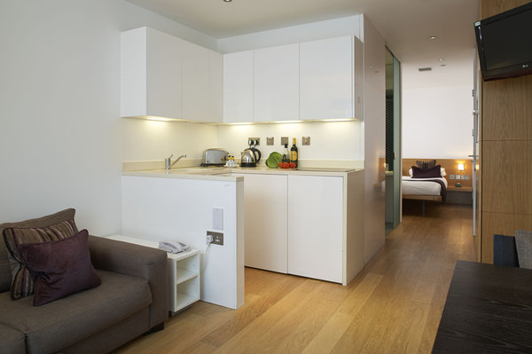

**K+K George Hotel – 15 minute walk**

* Wi-Fi is complimentary in public areas and all rooms
* Breakfast served 6.30-11 weekdays and weekends 7-11.30
* Complimentary gym open 6am-10pm and sauna 4pm-10pm
* Business centre is free of use

**Rooms**

* standard rooms have a Queen size bed
* classic rooms have a King size bed
* executive rooms have a King size bed and complimentary Samsung tablet to use within the premises
* Executive rooms are £30 extra, only 3 rooms with direct access to the private garden, complimentary fruit basket, bathrobe
* All rooms have safes satellite TV, telephones

**Conference rooms**

* Boardroom seats 16 boardroom style, 26 theatre style
* The Nevern room seats 24 boardroom style, 37 theatre style
* Garden restaurant available for private dining/meeting of up to 150 people

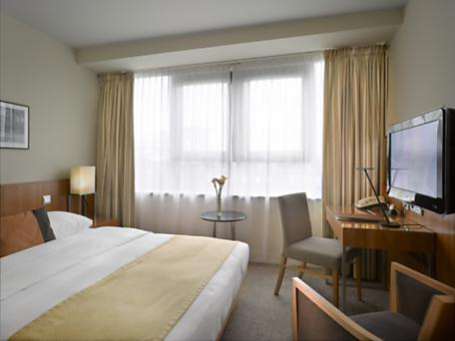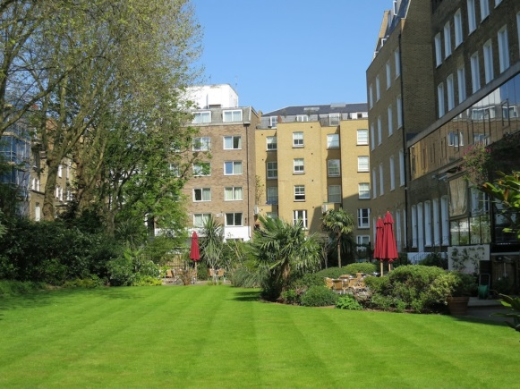

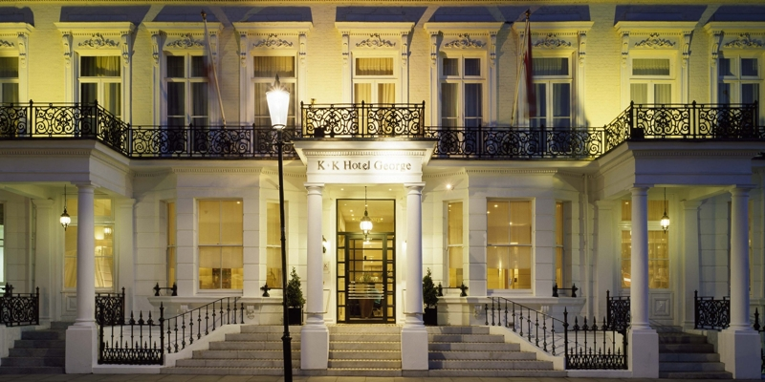

**Park International Hotel – 25 min walk**

* Wi-Fi £9 24 hours complimentary in the lobby
* Laptop sized safe, tea & coffee making facilities, small refrigerator, individually controlled air conditioning and heating, hair dryer and room service in all rooms
* (11) Triple and quad rooms available upon request
* Heritage suits available at higher rate upon request

**Dining**

* The orchid Breakfast room Breakfast served Mon – Sat 6.30-10am Sun 7.30-10.30am

Take away service is available by pre-ordering from reception the evening before

Any dietary requirements contact prior to arrival

* Piano bar & restaurant open 11am-1am with live piano nights Wed-Fri 7pm-12am

happy hour 5-7.30pm where draft beers and wine are half price

Snacks are served daily from 12-5.30pm

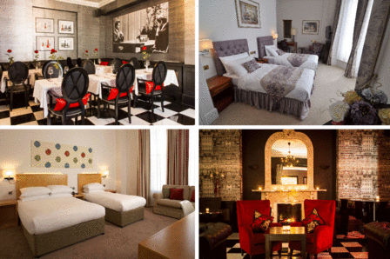

**Queen’s Gate Hotel 20 min public transport**

* Wi-Fi £10 per day
* Breakfast Mon-Fri 7-10am Sat-Sun 8-11am
* Fitness centre

**Rooms**

* LCD TV, air conditioning, mini bar (charged) , trouser press,
* Hair dryer, tea and coffee making facilities, English and continental sockets, en-suite bathroom, working desk and in-room safe.
* Triple and family rooms available upon request

**Conference** **rooms**

* Chelsea: 25 theatre style
* Kensington: 28 theatre style

**Dining**

* Bar English snack and Spanish tapas

**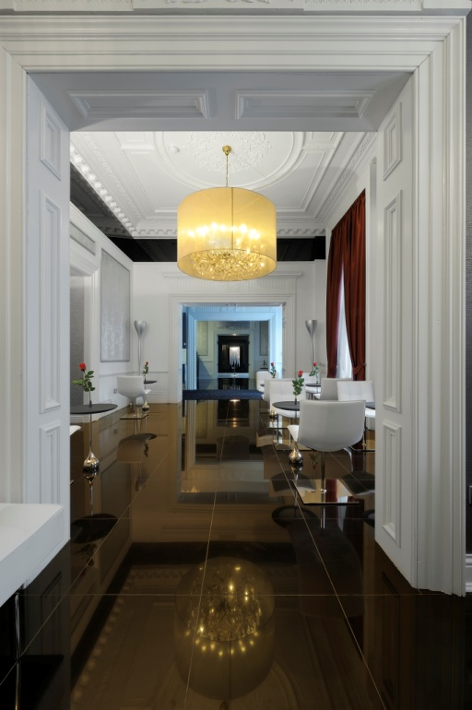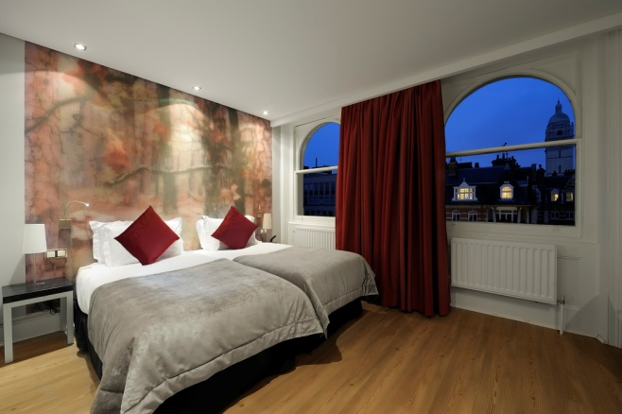**

**Crowne Plaza Kensington – 20 min public transport**

* Business centre
* Fitness centre
* Wi-Fi £15 per 24 hours

**Rooms**

* Flat screen TV, music docking station, work desk/chair, bath**,** tea/coffee making facilities,mini bar (charged)
* Standard room has double bed
* Executive room has king bed £60 supplement
* Executive suite has Queen bed £100 supplement

**Conference Rooms**

* Boardroom 16
* Garden roon 28 theatre style, 16 board room style
* Cromwell suite can be split into 3 parts:
  + Cromwell 1: 60 theatre style, 24 boardroom style
  + Cromwell 2: 40 theatre style, 18 boardroom style
  + Cromwell 3: 30 theatre style, 12 boardroom style

**Dining**

* Cocktail lounge
* Umami Restaurant: food from Thailand, Malaysia, Indonesia and Vietnam.

**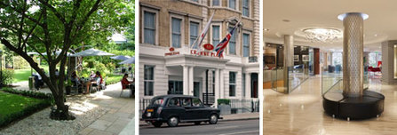**Breakfast, lunch and dinner served

* Bar open Mon-Sat 11am-1.30am and Sun 12pm-12am

****

****

**Grange Strathmore – 20 min public transport**

**Rooms**

* Charged Wi-Fi, tea/coffee making facilities, complimentary newspaper.
* Family rooms are available upon request
* Wake up calls are available upon request

**Conference rooms**

* The library 60 theatre 26 boardroom
* The study 25 theatre 15 boardroom
* There are other rooms which are used for different meeting/events depending upon your requirements

**Dining**

* Earls restaurant
  + Breakfast Mon-Sat 7-10am, Sun 7-11am
  + Lunch Mon-Sat 12-2.30pm
  + Dinner 6-10pm daily
* Glamis Lounge Bar cocktail, afternoon tea etc open 24 hours.

**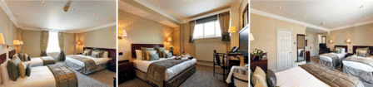**

****

**Hilton Kensington**

* Breakfast 6:30-10
* Wi-Fi £14.99
* Parking £32 24 hours
* Service animals and pets allowed. £35 non-refundable deposit maximum weight 75 lbs.
* Concierge desk
* Executive lounge and business centre
* Gym, sauna and steam room

**Rooms**

* Twin rooms
* Executive suit with sofa bed suitable for children
* Interconnecting rooms available
* Executive lounge

**Conference rooms**

* 11 function rooms 12-370
* 5 Hilton meeting rooms
* Video conferences services

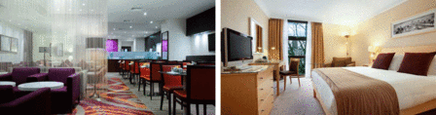

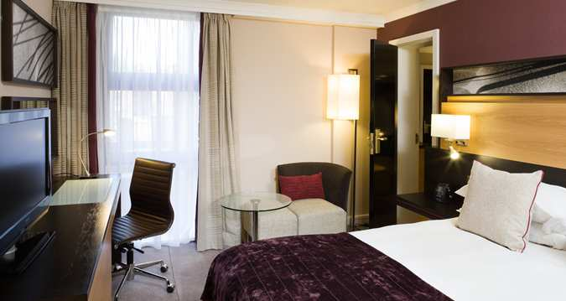

**NH Kensington – TRY AND GET FOR 2016**

* Breakfast Early Bird 5-6.30am, Mon-Fri 6.30-10am, Sat 6.30-11am, Sun 7am-12pm
* Garden Terrace
* Laundry/valet service, Dry cleaning service (paid service)
* Complimentary Wi-Fi throughout the hotel
* Indoor and outdoor parking available
* Children under 2 stay free
* One child up to age 11 may stay free

**Rooms**

* Work desk, mini bar, flat screen TV, soundproof window
* Cots available
* Room service
* Wake up service
* Wheelchair accessible
* Complimentary tea/coffee facilities

**Conference Rooms**

* 2 meeting rooms
  + Kent Room Reception 15 people
  + Sussex Room Reception 30 people and theatre 25 people
* Overhead projectors, TVs and DVD players, video conferencing and wireless internet access

**Dining**

* Breakfast buffet and al fresco meals in the Garden Lounge Bar
* Huntingdon’s Restaurant (Mediterranean) Dinner daily 6.30-11pm

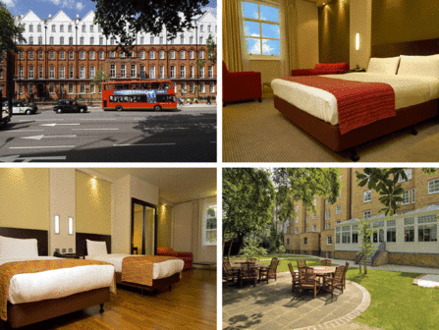

**Holiday Inn London Kensington Forum**

* Fitness room and free gym
* Breakfast Mon-Fri 6-10.30am, Sat-Sun 6-11am

**Rooms**

* Single, double and interconnecting rooms available
* Pillow menu, tea coffee making facilities, TV, individually controlled air conditioning
* Wi-Fi £16 per 24 hours
* Standard has no safe but safe deposit box at reception
* 1 child under 16 can stay free on the sofa bed in the executive room
* No mini bar in standard (mostly)

**Conference rooms**

* A variety of meeting rooms that carter between 15 and 300 people theatre style.

**Dining**

* Consortia Restaurant (European menu)

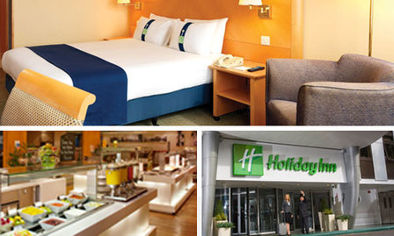

**The Kensington Hotel**

* Breakfast 7-10.30am
* Free Wi-Fi

**Rooms**

* LCD TV, media docking station
* Can accommodate for families
* Lap desks for use in bedrooms on request

**Dining**

* Aubrey Restaurant breakfast 7-10.30am, lunch 12-3pm, diner 5-10.30pm Bar & lounge service 11am-11pm, afternoon tea 3-6pm

**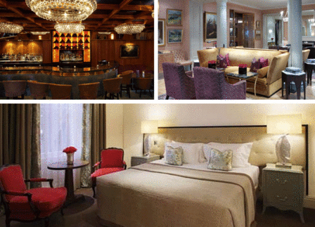**

**Millennium Bailey’s**

* Breakfast Mon-Fri 6.30-10.30am, Sat-Sun 7-11am
* Wi-Fi £20
* Business centre is charged
* Fitness centre is complimentary

**Rooms**

* standard room either double or twin beds, TV, telephone, charged mini bar, coffee and tea facilities, iron and ironing board
* nonsmoking rooms only
* club room is £50 supplement, also have access to club Lounge open 7am-10pm

**Conference rooms**

* Millennium Conference Centre has a total of 25 versatile function rooms

**Dining**

* + Olives bar
  + Olives Restaurant

**Baileys_Main.gif**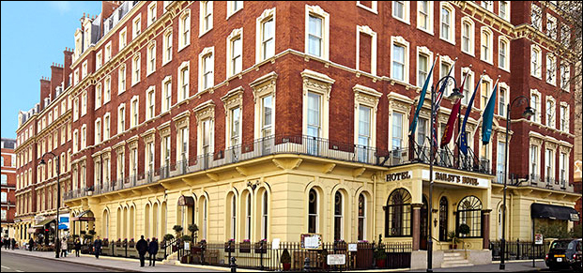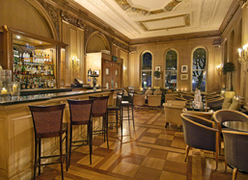**Millennium** **Gloucester**

* Breakfast: Mon – Fri
* Wi-Fi is additional charge
* Fitness centre is complimentary
* Chargeable parking

**Rooms**

* standard room either double or twin beds, TV, telephone, charged mini bar, coffee and tea facilities, iron and ironing board

**Conference rooms**

* + Sentosa suite seats 300 theatre style
  + Orchard suite seats 500 theatre style, 100 boardroom style
  + Kensington suite seats 150 theatre style, 80 boardroom style
  + Extra charge for AV equipment, refreshments and hire of room

**Dining**

* Bombay Brasserie (Indian)
* Bugis street Brasserie (Oriental)
* South West 7 (Breakfast)
* Humphrey’s Bar
* **Gloucester_Main.gif**Room service**Lancaster London Hotel**
* Breakfast served in Island Grill Mon-Sat 6.45-11am Sun 7-11am
* Free Wi-Fi in public areas, £15.50 in rooms 15 min complimentary
* Private check in for groups
* Car park 16-24 hours £40
* Free gym
* Lounge bar open until close

**Rooms**

* Charged mini bar, flat screen TV, air conditioning, complimentary toiletries, coffee/tea making facilities.
* Queen/twin beds

**Dining**

* ‘Picnic in the park’ available upon request
* Nipa Thai restaurant
* Island Grill – modern European dishes
* Lounge bar
* Afternoon tea

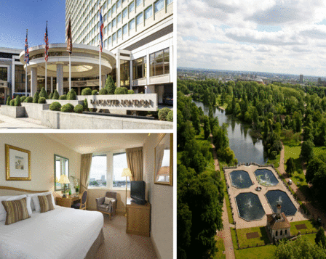

**Regency**

* Breakfast Mon-Fri 7-11am Sat-Sun 7.30-11am
* Wi-Fi £10 for 20 hours (only activated while you are logged on during your stay)
* Computer is £5 per hour

**Rooms**

* Queen’s Gate room
  + Ideal for families as some rooms can take up to 3 people
* Queen’s Gate and club rooms
  + Free Wi-Fi
  + Free access to the fitness centre
  + Free access to **Elysium Lounge**
    - Open 7am-10pm
    - Breakfast served 7-9am
    - Free tea/coffee facilities throughout the day
    - Complimentary drinks between 6-8pm
    - Free Wi-Fi

**Conference rooms**

* Conference centre, Regency has a range of facilities for conferences and meetings
* Call hotel for more information about your requirements and costs

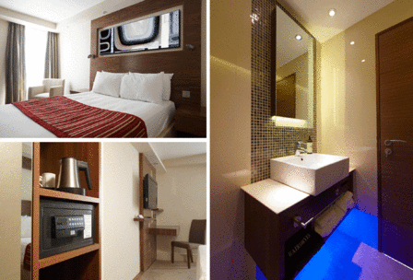

**The Rembrandt Hotel**

* Complimentary Wi-Fi
* Breakfast Mon-Fri 7-10 Sat-Sun 7.30-10
* Free cash withdrawals
* £7.50 access to gym Mon-Fri 7am-10pm Sat-Sun 8am-8pm, unpaid classes (list available outside fitness room) Swimming pool, swimming lessons 9am-5pm. Sauna, steam, changing rooms, towels and toiletries available.

**Rooms**

* Balconies available (open at request and signed contract required)
* tea & coffee facilities, TV digital and pay movies, tea/coffee facilities, international plug, complementary dial up system and Free Wi-Fi throughout the hotel
* Superior – double/twin bed
* Executive - king/double/ twin beds, mini bar, Jacuzzi bath at request, laptop size safe,

**Conference rooms**

* A variety of meeting rooms suitable for boardroom, theatre and cabaret style
* The Edward suite - 60 theatre, 26 boardroom, 24 cabaret
* The Princess suite - 24 theatre, 16 boardroom, 18 cabaret
* The Victoria suite – 20 theatre, 15 boardroom
* Boardroom – 14 boardroom

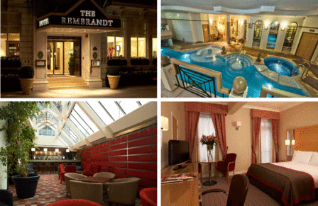

**Dorsett Shepherds Bush**

* Free Wi-Fi
* Breakfast from…
* 24 hour gym

**Rooms**

* Dorsett Standard Rooms: Complimentary Wi-Fi, cable television, work desk, docking stations, chargeable mini bar, tea/coffee facility, safe, iron and ironing boards
* Deluxe Room: similar to standard room
* Executive Room: more spacious, bathrobe, slippers, serving drinks and canapé’s before dinner
* All nonsmoking rooms

**Conference Rooms**

* 3 meeting rooms available:
* One larger board room style, with a smart board, maximum 14 delegates
* 2nd room, 60 inch TV with a maximum capacity of 10 people
* 3rd room, board room that accommodates 8
* All 3 accommodated with latest multimedia technology and wireless internet

**Restaurants**

* Pictures, in house restaurant: contemporary brasserie style menu, complimented by a selection of handpicked Asian inspired dishes
* Jin, Atrium bar: open from 9am, serves tea/coffee, cocktails, fine wines, beers

